**Technology System Installation**

1. Run **UltraVNC_1_2_11_X86_Setup** setup Ok

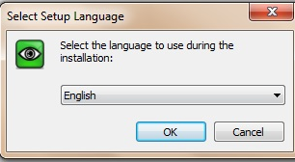

1. **Accept agreement** Next

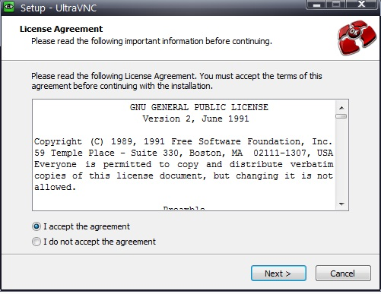

1. **Next**

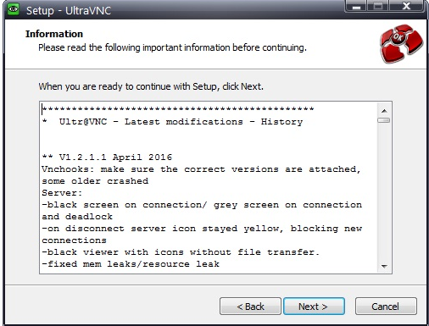

1. select **Ultra VNC Viewer**  Next

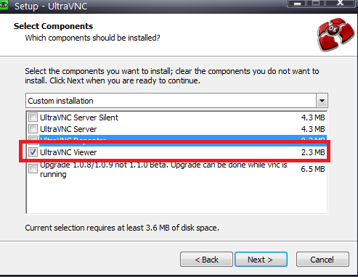

1. Select Below option Next

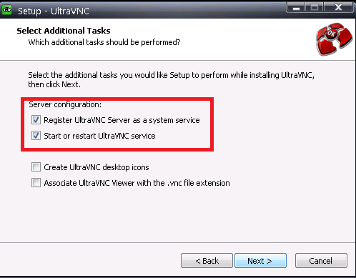

1. **Install**

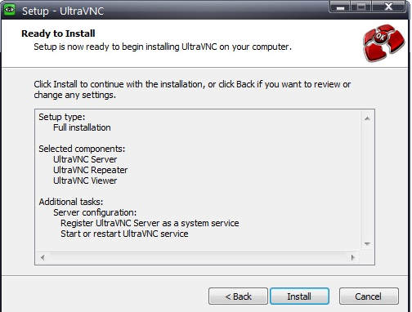

1. Next

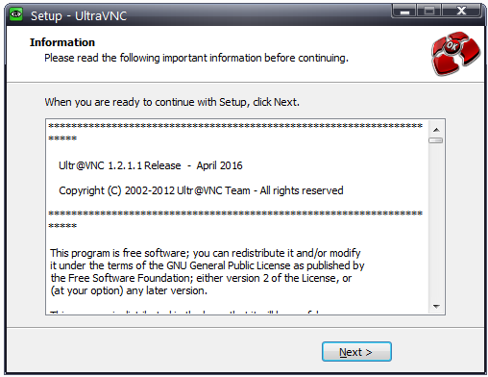

1. Finish(system will restart)

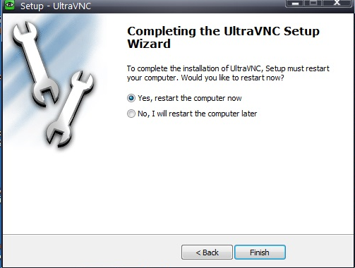

**Thank You**